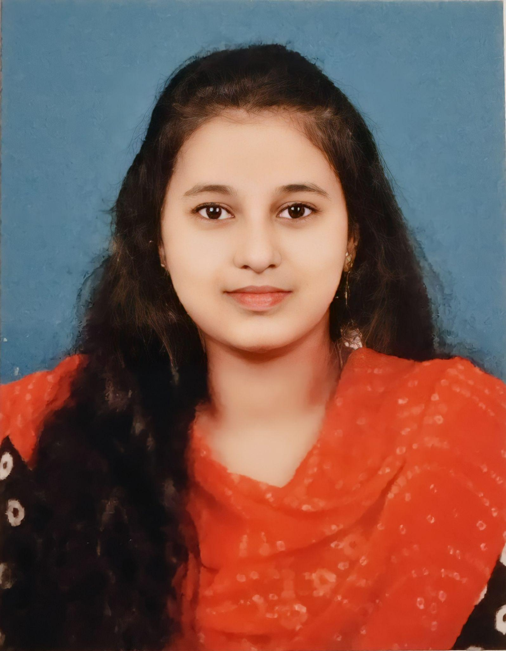Shafeera.Z

Mobile :9790620639

E-Mail :kit.23.19bec102@gmail.com

**OBJECTIVE**

Looking for a challenging role in a reputable organization to utilize my technical, database, and management skills for the growth of the organization as well as to enhance my knowledge about new and emerging trends in the IT sector.

**ACADEMIC PROFILE**

| **Name of the Course/Specialization** | **Name of the School/College** | **Year of Passing** | **CGPA/Percentage** |
| --- | --- | --- | --- |
| BE-Electronics and Communication Engineering | KIT-Kalaignar Karunanidhi Institute of Technology,Coimbatore. | 2019-2023  (Pursuing) | 8.821%(as of 5 th semester) |
| HSC(State Board)-Computer Maths | Blue Bird Matriculation Higher Secondary School,Palladam,Tirupur district. | 2017-2019 | 82.3% |
| SSLC(State Board)-General | Blue Bird Matriculation Higher Secondary School,Palladam,Tirupur district. | 2017 | 97.2% |

**TECHNICAL SKILLS**

* Programming Skills: **C** , **Python**
* Markup Languages : **HTML/CSS**

**AREA OF INTEREST**

* **Problem Solving** in **C** and **Python**
* Basic Electronics.

**INTERNSHIP AND IN-PLANT TRAINING**

* Attended Internship training on **Web Designing** from July 15 to July 31, 2021 at Ether Infotech.
* Attended In-plant training on **Web designing** from March 19 to March 25, 2021 at Appin Technology lab.

**PROJECTS**

* Done a Mini-project on WebDesigning by creating an **Ecommerce Website.**

**CERTIFICATES AND ACHIEVEMENTS**

* Completed **Certification Course** on **JAVA programming** and **FULL STACK DATA SCIENCE** **with PYTHON,NUMPY and R programming**.
* Earned **HackerRank Certificate** for clearing the Assessment in **PYTHON(BASIC)** and Earned GOLD badge in C and PYTHON programming and SILVER badge in JAVA programming in **HackerRank**
* **Total Hackos** earned in HackerRank:**31346**

**PERSONAL DETAILS**

Date of Birth **:** 19.07.2001

Father’s Name **:** M.Zahur Basha

Permanent Address **:** 65A,New Extension Street,PRA lodge opposite,West

Palladam,Palladam-641664

Gender **:** Female

Nationality  **:** Indian

Languages Known **:**  English,Hindi,Tamil,Urdu.

**REFERENCE**

Name **:** Prof.R.Gowrishankar

Designation **:** Head of the Department

Institution **:** KIT-Kalaignarkarunanidhi Institute of Technology,Coimbatore

Email I’d **:** [rgowri2017@gmail.com](mailto:rgowri2017@gmail.com)

Contact **:** +91 98653 77331

**DECLARATION**

I hereby declare that all the above information mentioned is true and correct to the best of my knowledge.

**PLACE:** Coimbatore.

**DATE :** Signature,

